

**Department of**

**Computer Science and Engineering**

**Lab Report - 05**

Course No.              : CSE-308

Course Title             : System Analysis and Design Laboratory

Submitted By         :

  Name : 1 . Tasmim Sultana(129)

  2 . Fatama Jannat Tisha (131)

                                   3 .  Kamelia Zaman Moon (299)

                               4  .Umma Salma (302)

                                   5 . Sabrina Afrin Toma (304)

         Session        : 2017-18

         Semester     : 3rd year 1st Semester

Date            : 19-07-2020

Submitted To:

Md Musfique Anwar

         Associate Professor, Department of Computer Science and Engineering

         Dr. Md Humayun Kabir

Professor, Department of Computer Science and Engineering

Jahangirnagar University, Savar

**Experiment No**: 05

**Title**: Class Diagram for Online Class & Examination System.

**Objective**: To design a class diagram for our selected project that we are going to implement. Class diagrams describe systems by illustrating attributes, operations and relationships between classes.

**Procedure:**

1. We use an online tool to make our class diagram.
2. At first we identified our required classes for this project.
3. We determine the necessary attribute and functionality for each of the classes.
4. Then we show the relationship among the classes.

**Diagram:**

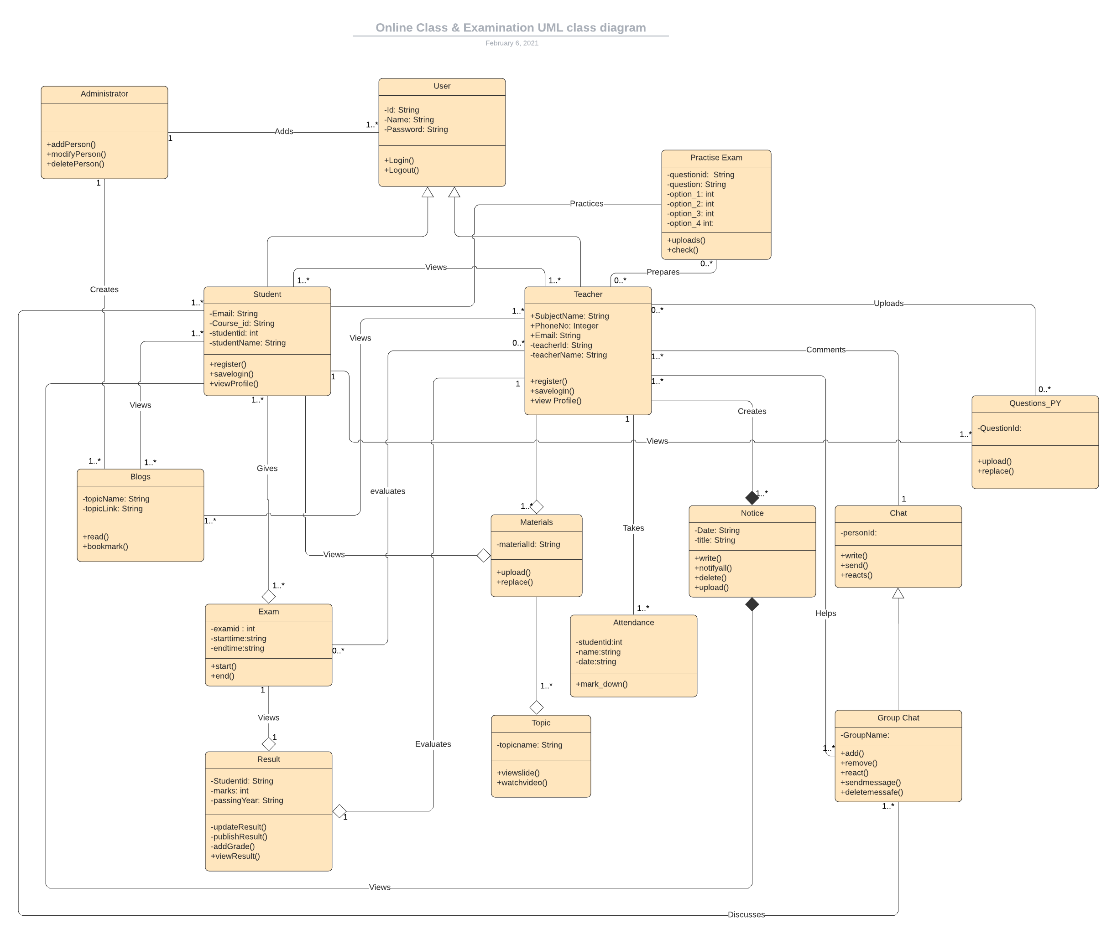

**Discussion:** This class diagram gives us the ability to create models with the help of UML using attributes, relationships, operations and intersections. Class diagrams visualize the paths between classes in the form of aggregations and associations as well as through the passing on of properties and behavior between classes. These take the form of generalization.

Class diagrams are the most important kind of UML diagram and are vitally important in software development. The class diagram of the online class and examination system will make it easy to implement our project in a better way.